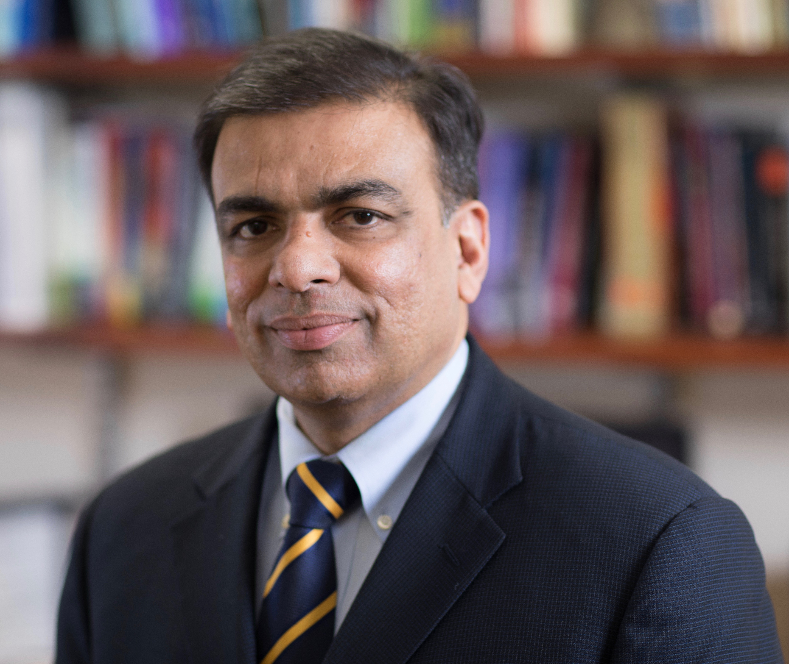
Joe Verghese, MBBS, MS

Professor of Neurology & Medicine,
Chief, Integrated Divisions of Cognitive & Motor Aging and Geriatrics,
Murray D Gross Memorial Faculty Scholar in Gerontology,
Founding Director, Montefiore-Einstein Center for the Aging Brain

Departments of Neurology and Medicine,
Albert Einstein College of Medicine,
Bronx, NY 10461, USA

E-mail: joe.verghese@einsteinmed.org

Administrative Assistant: Donna Brandon (donna.brandon@einsteinmed.org)
Tel: 718 430 3808, Fax: 718 430 3829

Dr. Joe Verghese graduated from St. Johns Medical College, Bangalore, India. He did his postgraduate training in Internal Medicine and Neurology in United Kingdom. He completed his Neurology residency at the Albert Einstein College of Medicine, Bronx, NY. He did fellowship training in Neurophysiology as well as Aging & Dementia in 1999 at the same institution. He received a Master of Science degree in Clinical Research Methods with Distinction from the Albert Einstein College of Medicine in 2001. Dr. Verghese is board-Certified in Neurology.

Dr. Verghese is Professor of Neurology and Medicine at the Albert Einstein College of Medicine. He is the Chief of the integrated divisions of Cognitive & Motor Aging in the Department of Neurology and Geriatrics in the Department of Medicine. He is the founding Director of the Montefiore-Einstein Center for the Aging Brain, an interdisciplinary cognitive assessment center.

Dr. Verghese’s research interest is the effects of disease and aging on mobility and cognition in older adults, and he has over 250 peer-reviewed publications and several federally funded research grants in these areas. His current projects include non-pharmacological intervention trials for reducing risk of dementia and mobility loss, cognitive control of gait and mobility, and global health studies in dementia.

